

Welcome, new owner of a brand new Purolett combustion toilet You have just received your very own Swedish-made easy-care, environmentally friendly and last but not least safe combustion toilet. It will serve you well for years to come!

Purolett has been developed with care for both its user and the environment. We at Purolett do not think that restroom convenience should be limited to those with access to plumbing, and we know that often many people might have to go at the same time, so capacity is important too. Therefore, we have taken the technology behind combustion toilets a little further. With the use of double heating coils and the most energy-efficient fan on the market, Purolett is easier on the wallet and the environment than many alternatives - and has significantly greater capacity to boot! Purolett is suitable for both small and large families, even on merry occasions with many visitors. This user manual contains all the information you need to use it correctly!

The Benefits of Purolett
• Easy to use
• Child safe
• Energy efficient
• Effective
• Fitted with a catalytic filter, Included in Royal, Optional for Elit
• Antibacterial seat
• Double heating coils
• Minimal impact on indoor climate with its closed air system.
• Easy to service and maintain
• Can handle 12–14 people / day
• Comes with a 3 year warranty.
• A large Ash capacity of 9 liters

How to use Purolett
• Flick the power switches (three in total, the red one is lit even when turned off) on the left side.
• Open the toilet lid and place a disposable bag in the toilet bowl. A new bag must be placed before each use. When the bag is in place, the toilet is ready for use.
• Use the restroom.
• Flush the toilet by pressing the flushing-lever down gently. This will open a hatch that empties the contents of the bowl into the combustion chamber.
Flush again and check to make sure the entire bag has fallen down properly.
• Twist the the timer to “start”. This begins combustion, first liquids evaporate away and then solid waste will be incinerated.
• The recommended time for combustion is 55 minutes, but if there is only liquid waste, 35 minutes will suffice.
• It is possible to use the toilet even when incineration is in progress. Simply add 20 minutes to the timer per extra use. After four consecutive uses, however, the toilet needs to cool down. The toilet is properly cooled once the fan stops spinning.

Advice! You figure out yourself precisely how long the combustion takes. Try setting the timer at different times and check if the waste has been incinerated. This way you can save time, money and the environment!

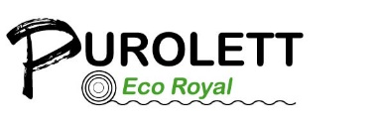

MADE IN SWEDEN

How to use the Purolett Combustion Toilet.

Start by flicking the three switches on the left side.
Then open the toilet lid and put a toilet bag in the bowl. Then once you push the flushing lever, a hatch opens and empties the contents of the bowl into the combustion chamber. You can start the combustion process before use, this will aid the flushing process.
Start combustion by setting the timer to “start”. This begins combustion, first liquid waste evaporates, then solid waste will combust and leave behind no more than a bit of ash. One month´s use of the toilet will result in about one teacup´s worth of ash, which can be safely thrown away like regular ashes.
The fan will continue to run until the toilet has cooled down.
The toilet can also be used repeatedly even when running up to 4 times consecutively, after which it needs to cool down.
With some experimentation you can find out yourself exactly how long combustion will take. We suggest you try different timings and check if combustion has completed. If liquid waste is added at the end of a end of an incineration cycle, you can even try not to increase the time at all, as the urine will boil away and the paper will incinerate with the next use.

Installation
Opening need to be drilled for for the inlet and air exhaust.
The lower opening on the back INLET the center of which should be 16.5 cm ( or 6.5 inches) from the floor.
The upper opening at the back EXHAUST, the center of which should be 39.5 cm ( or 15.5 inches) from the floor.
Drilled with a 111mm socket drill.
An 8mm hole must be drilled in the bottom of the 90 degree bend closest to the toilet to get rid of any condensation.
NOTE! No nets, meshes or filters may be put in front of the inlet or exuast. And it must not be screwed to the floor.

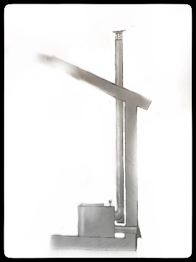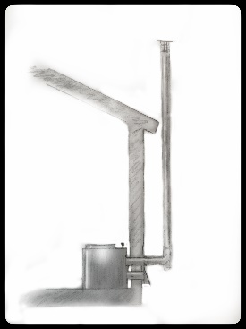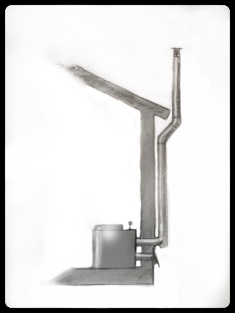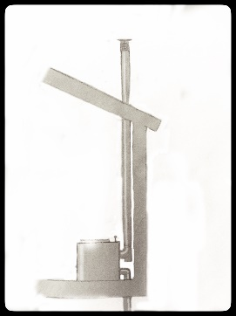

You need to supply the following materials yourself.
• a 110 mm gray drain pipe. Use a maximum of 4, 45-degree bends or 2, 90-degree bends.
• Straight pipes, with a maximum length of 10 meters. When using pipe bends, the maximum is instead 6.5 meters.
• Wall brackets, for fastening.

You need the following tools.
• Drilling machine
• Hole saw, 111 mm, for drilling holes for the inlet and exhaust pipes.
• Long drill for guide holes through wall.
• A hackaw and a knife
• A folding rule or measuring tape
• Marker pen
• Rasp and / or file
• A bubble or spirit level
• Screwdriver and chisels
• And a hammer
The white circular plastic tray / Used to seal the inlet
Does not apply to models with convection protection.

Sealing the inlet with the plastic tray is the last step before you push the toilet into place. To do this simply remove the protective film on the double-sided adhesive tape.
Thread it onto the air pipe with the tape facing the room.
Slide the toilet into place and make sure that both the inlet and the exhaust pipes are in the correct position relative to the toilet.
Now push the white plastic ring so that it is properly adhered to the back of the toilet to seal the inlet, (use the picture below for reference) The white circular tray is not needed for the Eco Royal model or for Eco Elite which have convection protection installed.
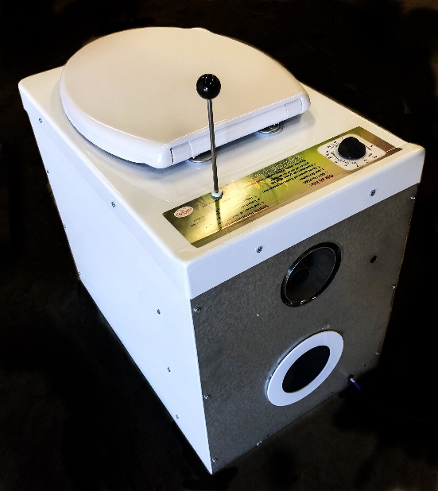
Chimney Cap
PUROLETT

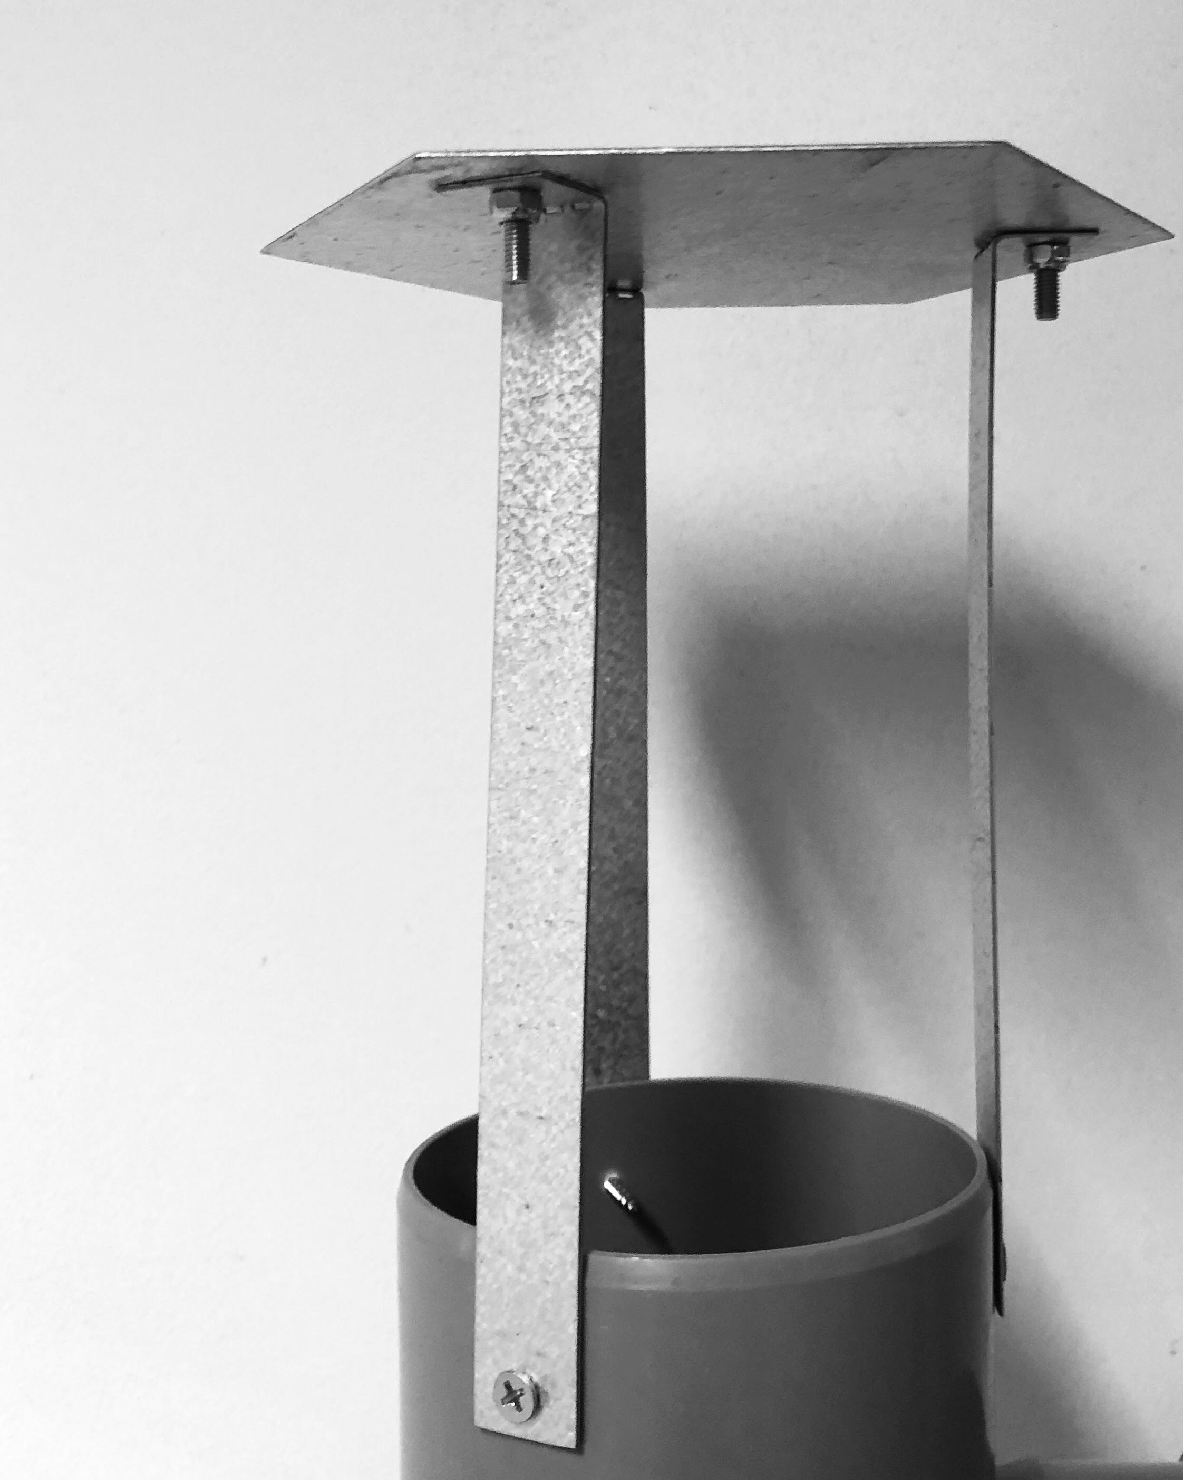

Mounted as shown above, put it as high as possible on the exhaust pipe.
If not placed as in the picture, the toilet will overheat.
No nets, meshes or filters may be used with the chimney top,
Nor with the inlet.

Frequently asked questions / additional information

The fan does not start.
Make sure that your Purolett is plugged in and has a proper supply of power.

The ground fault interrupter engages.
(It must be connected to one as such)
First turn try turning of off one of the heating coils, and then try again.
If the ground fault interrupter engages again, try the same method but with the other heating coil.

This problem can be caused by moisture on one of the heating coils. In many cases, this can be solved by running the toilet with the working heating coil for 30 minutes to get rid of the moisture.
When it has cooled down, you can try turning on the dysfunctional coil again to see if the interrupter engages again.
If it does, the coil is broken and needs to be replaced. Do note, you can still use your Purolett without issue, as long as you keep the dysfunctional coil switched off.
When using the machine with just one coil you must however increase the combustion time as it will run at half capacity. Roughly doubling of the timer usually works about right, you will be able to see for yourself to what extent this timing works for you.

No heat is being produced.
First check if the thermal protection circuit has been engaged. This circuit can be reset with a switch on the back of the toilet. This switch is located behind a small white plastic cap. It will click if triggered.
If it engages again, check inlet and outlet pipes to make sure they are not blocked or congested in any way.
Also check to make sure there are no paper scraps around the rectangular hole at the top of the combustion chamber. If the bag does not properly go through the hatch into the combustion chamber, paper can get stuck and cause overheating.

The fan does not continue to spin after a completed cycle.
The fan on your Purolett should always run for an extra 35 minutes after the timer has run out. If it does not, you must start it with the two heating elements turned off. These are manually switched off with the two white switches on the side of the toilet. Running the timer at for 35 minutes will then engage just the fan.
Contact your retailer to ask for repairs if the problem persists.

Maintenance / cleaning
Your Purolett does not need regular service, just regular cleaning. Over time salt will accumulate in the ash pot as it cannot evaporate. To remove the salt simply fill the ash pot with water and leae it for couple of hours, a few drops of vinegar in the water facilitates the process.
The exhaust air also needs to be cleaned occasionally, preferably twice a year. In addition to this, your Purolett is to be cleaned just like a regular toilet.

Important information for those of you who have a Purolett whose timer decal is marked MAX
This marking should not be construed as a prohibition on turning the timer past this position. When several people use the toilet, more time must be added on the timer for each use to complete combustion, in these instances the timer might have to be twisted beyond MAX.

For more information visit: www.purolett.se
Or call +4687920128

